## Winter Semester 2022

CSE250 Database Management System

## horizontal line

## Plastic Waste Management

AU2040193 Yash Chotaliya

AU2040199 Akshay Parmar

AU2040226 Tushar Vaghela

AU2040202 Dhruv Patel



Commerce Six Roads, Naranpark Society, Navrangpura, Ahmedabad, Gujarat,380009

# Overview

In our project we try to connect the user(waste producer in our case) which is the starting point and government/private waste collector which is the end point. We build the design in such a way that users can decide their own what type of waste collector(government/private) he/she wants. First the user has to sign in after that he/she/entity can fill up the information(like waste type,approx waste weight) and for the waste, then the user can complain regarding the waste and he/she can also select the type of waste collector whatever he/she/entity wants (government or private), the website can automatically display the government/private company name and information according to user address(by comparing the area). After submitting the information the waste collector gets the information whatever the user gave and within such a time period the collector collects the waste from users. Here, the waste collector is according to user choice government/private. After providing the type, according to that type of collector whichever is currently available near the users area they get the information and collect the waste from the user.

# ER-Diagram

Here, there are many-many relationship tables. So, after applying normalization, we had created a weak entity table which depended on the other strong entity.

# Relationship Diagram

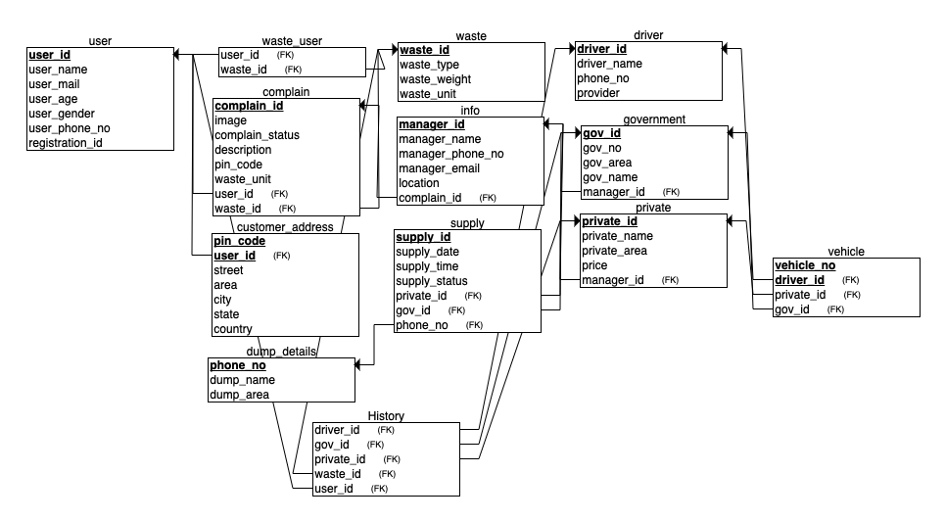

## 

## 

## 

## **Table Creation code and image**

**1). User table**

CREATE TABLE us_er

(

user_id INT,

user_name CHAR(50),

user_mail CHAR(50),

user_age INT,

user_gender CHAR(50),

user_phone_no INT,

registration_id INT,

PRIMARY KEY (user_id)

);

insert into us_er values (101,'user1','user1@gmail.com', 20, 'male', 1111111111, 201);

insert into us_er values (102,'user2','user2@gmail.com', 21, 'female', 1111111112, 202);

insert into us_er values (103,'user3','user3@gmail.com', 22, 'male', 1111111113, 203);

insert into us_er values (104,'user4','user4@gmail.com', 23, 'female', 1111111114, 204);

insert into us_er values (105,'user5','user5@gmail.com', 24, 'male', 1111111115, 205);

select * from us_er;

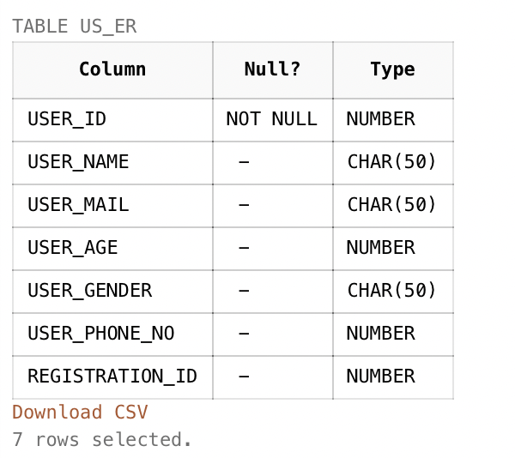

**2). Waste table**

CREATE TABLE waste

(

waste_type CHAR(50),

waste_weight INT,

waste_unit CHAR(50),

waste_id INT,

PRIMARY KEY (waste_id)

);

insert into waste values ('type1', 1,'kg', 301);

insert into waste values ('type2', 2,'kg', 302);

insert into waste values ('type3', 3,'kg', 303);

insert into waste values ('type4', 4,'kg', 304);

insert into waste values ('type5', 5,'kg', 305);

select * from waste;

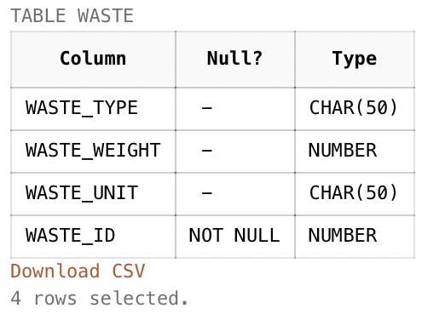

**3). Complain table**

CREATE TABLE complain

(

complain_id INT,

image INT,

complain_status CHAR(50),

description CHAR(50),

pin_code INT,

waste_unit INT,

user_id INT,

waste_id INT,

PRIMARY KEY (complain_id),

FOREIGN KEY (user_id) REFERENCES us_er(user_id),

FOREIGN KEY (waste_id) REFERENCES waste(waste_id)

);

insert into complain values (401, 10, 'complete', 'description1', 100000, 1, 101, 301);

insert into complain values (402, 11, 'incomplete', 'description2', 200000, 2, 102, 302);

insert into complain values (403, 12, 'complete', 'description3', 300000, 3, 103, 303);

insert into complain values (404, 13, 'incomplete', 'description4', 400000, 4, 104, 304);

insert into complain values (405, 14, 'complete', 'description5', 500000, 5, 105, 305);

select * from complain;

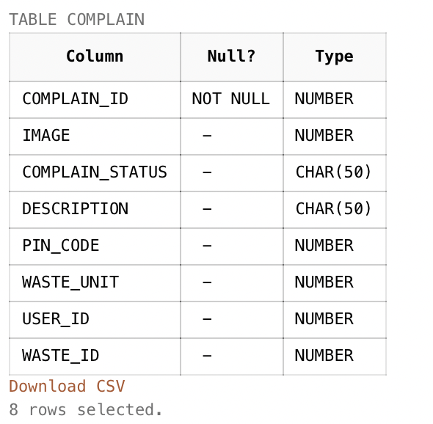

**4). Customer address table**

CREATE TABLE customer_address

(

pin_code INT,

street CHAR(50),

area CHAR(50),

city CHAR(50),

state CHAR(50),

country CHAR(50),

user_id INT,

PRIMARY KEY (pin_code, user_id),

FOREIGN KEY (user_id) REFERENCES us_er(user_id)

);

insert into customer_address values (100000, 'street1', 'area1', 'city1', 'state1', 'country1', 101);

insert into customer_address values (200000, 'street2', 'area2', 'city2', 'state2', 'country2', 102);

insert into customer_address values (300000, 'street3', 'area3', 'city3', 'state3', 'country3', 103);

insert into customer_address values (400000, 'street4', 'area4', 'city4', 'state4', 'country4', 104);

insert into customer_address values (500000, 'street5', 'area5', 'city5', 'state5', 'country5', 105);

select * from customer_address;

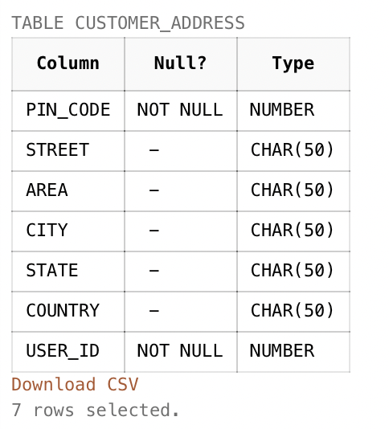

**5). Backend information manager details table**

CREATE TABLE info

(

manager_id INT,

manager_name CHAR(50),

manager_phone_no INT,

manager_email CHAR(50),

location CHAR(60),

complain_id INT,

PRIMARY KEY (manager_id),

FOREIGN KEY (complain_id) REFERENCES complain(complain_id)

);

insert into info values (501, 'mname1', 1111111121, 'mname1@gamil.com', 'location1', 401);

insert into info values (502, 'mname2', 1111111122, 'mname2@gamil.com', 'location2', 402);

insert into info values (503, 'mname3', 1111111123, 'mname3@gamil.com', 'location3', 403);

insert into info values (504, 'mname4', 1111111124, 'mname4@gamil.com', 'location4', 404);

insert into info values (505, 'mname5', 1111111125, 'mname5@gamil.com', 'location5', 405);

select * from info;

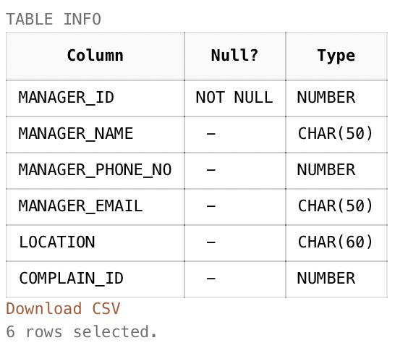

**6). Government company details table**

CREATE TABLE government

(

gov_id INT,

gov_no INT,

gov_area CHAR(50),

gov_name CHAR(50),

manager_id INT,

PRIMARY KEY (gov_id),

FOREIGN KEY (manager_id) REFERENCES info(manager_id)

);

insert into government values (601, 21, 'garea1','gname1', 501);

insert into government values (602, 22, 'garea2','gname2', 502);

insert into government values (603, 23, 'garea3','gname3', 503);

insert into government values (604, 24, 'garea4','gname4', 504);

insert into government values (605, 25, 'garea5','gname5', 505);

select * from government;

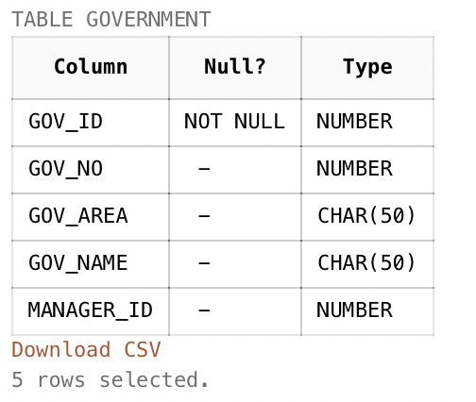

**7). Private company details table**

CREATE TABLE private

(

private_id INT,

private_name CHAR(50),

private_area CHAR(50),

price INT,

manager_id INT,

PRIMARY KEY (private_id),

FOREIGN KEY (manager_id) REFERENCES info(manager_id)

);

insert into private values (701, 'pname1', 'parea1', 100, 501);

insert into private values (702, 'pname2', 'parea2', 110, 502);

insert into private values (703, 'pname3', 'parea3', 120, 503);

insert into private values (704, 'pname4', 'parea4', 130, 504);

insert into private values (705, 'pname5', 'parea5', 140, 505);

select * from private;

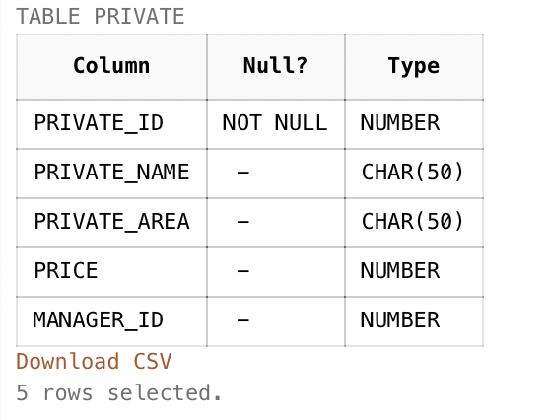

**8). Drivers details table**

CREATE TABLE driver

(

driver_id INT,

driver_name CHAR(50),

phone_no INT,

provider CHAR(50),

PRIMARY KEY (driver_id)

);

insert into driver values (801, 'dname1', 1111111131, 'provider1');

insert into driver values (802, 'dname2', 1111111132, 'provider2');

insert into driver values (803, 'dname3', 1111111133, 'provider3');

insert into driver values (804, 'dname4', 1111111134, 'provider4');

insert into driver values (805, 'dname5', 1111111135, 'provider5');

select * from driver;

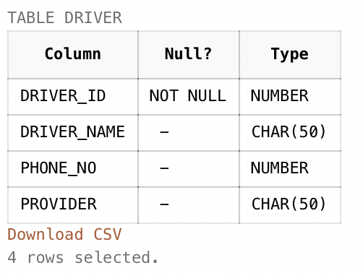

**9). Dumping area information table**

CREATE TABLE dump_details

(

dump_name CHAR(50),

dump_area CHAR(50),

phone_no INT,

PRIMARY KEY (phone_no)

);

insert into dump_details values ('dumpname1', 'dumparea1', 1111111131);

insert into dump_details values ('dumpname2', 'dumparea2', 1111111132);

insert into dump_details values ('dumpname3', 'dumparea3', 1111111133);

insert into dump_details values ('dumpname4', 'dumparea4', 1111111134);

insert into dump_details values ('dumpname5', 'dumparea5', 1111111135);

select * from dump_details;

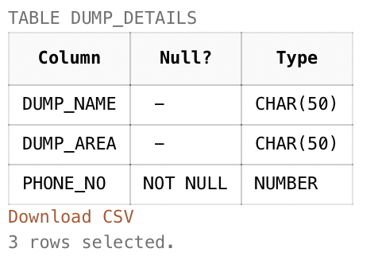

**10). User Complain History table**

CREATE TABLE History

(

driver_id INT,

gov_id INT,

private_id INT,

waste_id INT,

user_id INT,

FOREIGN KEY (driver_id) REFERENCES driver(driver_id),

FOREIGN KEY (gov_id) REFERENCES government(gov_id),

FOREIGN KEY (private_id) REFERENCES private(private_id),

FOREIGN KEY (waste_id) REFERENCES waste(waste_id),

FOREIGN KEY (user_id) REFERENCES us_er(user_id)

);

insert into History values (801, 601, 701, 301, 101);

insert into History values (802, 602, 702, 302, 102);

insert into History values (803, 603, 703, 303, 103);

insert into History values (804, 604, 704, 304, 104);

insert into History values (805, 605, 705, 305, 105);

select * from History;

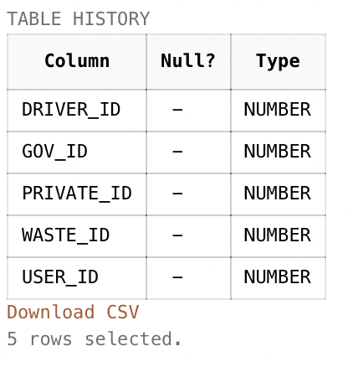

**11). User and Complain waste type details table**

CREATE TABLE waste_user

(

user_id INT,

waste_id INT,

FOREIGN KEY (user_id) REFERENCES us_er(user_id),

FOREIGN KEY (waste_id) REFERENCES waste(waste_id)

);

insert into waste_user values (101, 301);

insert into waste_user values (102, 302);

insert into waste_user values (103, 303);

insert into waste_user values (104, 304);

insert into waste_user values (105, 305);

select * from waste_user;

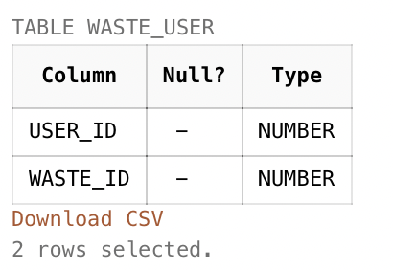

**12). Vehicle details table**

CREATE TABLE vehicle

(

vehicle_no CHAR(50),

driver_id INT,

private_id INT,

gov_id INT,

PRIMARY KEY (vehicle_no, driver_id),

FOREIGN KEY (driver_id) REFERENCES driver(driver_id),

FOREIGN KEY (private_id) REFERENCES private(private_id),

FOREIGN KEY (gov_id) REFERENCES government(gov_id)

);

insert into vehicle values ('a901', 801, 701, 601);

insert into vehicle values ('a902', 802, 702, 602);

insert into vehicle values ('a903', 803, 703, 603);

insert into vehicle values ('a904', 804, 704, 604);

insert into vehicle values ('a905', 805, 705, 605);

select * from vehicle;

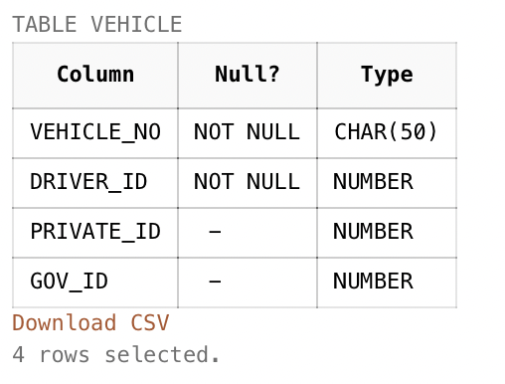

**13). Supply Information table Connected to Government and Private company**

CREATE TABLE supply

(

supply_date DATE,

supply_time DATE,

supply_status CHAR(50),

supply_id INT,

private_id INT,

gov_id INT,

phone_no INT,

PRIMARY KEY (supply_id),

FOREIGN KEY (private_id) REFERENCES private(private_id),

FOREIGN KEY (gov_id) REFERENCES government(gov_id),

FOREIGN KEY (phone_no) REFERENCES dump_details(phone_no)

);

insert into supply values ('01-april-2022', '01-april-2022', 'complete', 1001, 701, 601, 1111111131);

insert into supply values ('02-april-2022', '02-april-2022', 'incomplete', 1002, 702, 602, 1111111132);

insert into supply values ('03-april-2022', '03-april-2022', 'complete', 1003, 703, 603, 1111111133);

insert into supply values ('04-april-2022', '04-april-2022', 'incomplete', 1004, 704, 604, 1111111134);

insert into supply values ('05-april-2022', '05-april-2022', 'complete', 1005, 705, 605, 1111111135);

select * from supply;

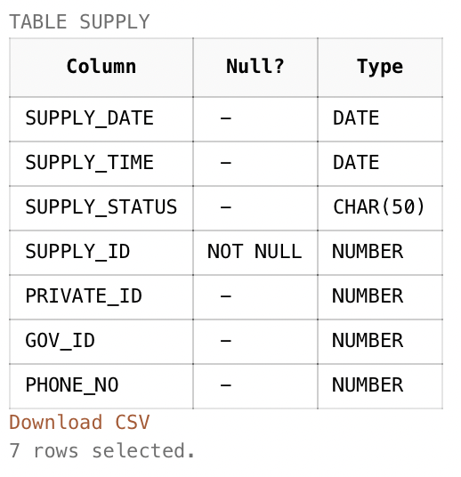

**14). Temporary table used in procedure, function and trigger**

CREATE TABLE temp

(

complain_id INT,

image INT,

complain_status CHAR(50),

description CHAR(50),

pin_code INT, waste_unit INT,

user_id INT,

waste_id INT,

waste_type CHAR(50),

waste_weight INT

);

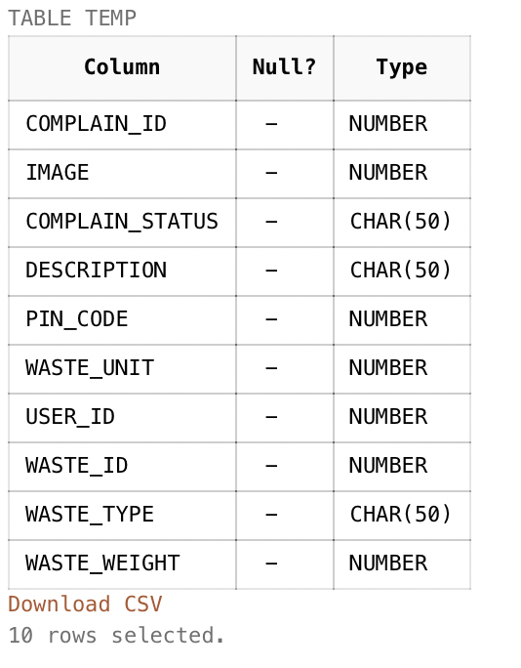

**15). Temporary table used in procedure, function and trigger**

CREATE TABLE temp2

(

pin_code INT,

street CHAR(50),

area CHAR(50),

city CHAR(50),

state CHAR(50),

country CHAR(50),

user_id INT,

PRIMARY KEY (pin_code, user_id),

FOREIGN KEY (user_id) REFERENCES us_er(user_id)

);

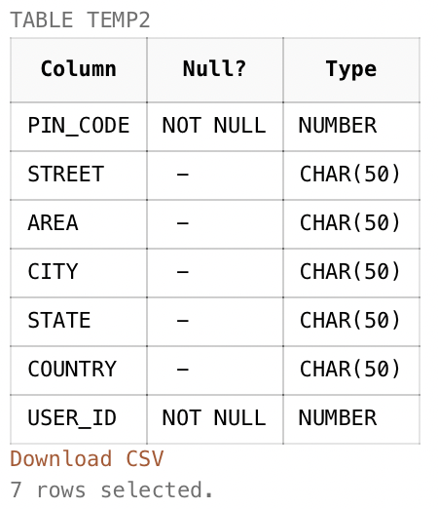

# Procedure, Function and Trigger

## **Procedure**

**1. Procedure (Managers Information)**

create or replace procedure us_info as

cursor c_p is select * from info;

r_p c_p%rowtype;

begin

for r_p in c_p loop

dbms_output.put_line(r_p.manager_name || r_p.manager_phone_no || r_p.manager_email || r_p.location);

end loop;

end;

/

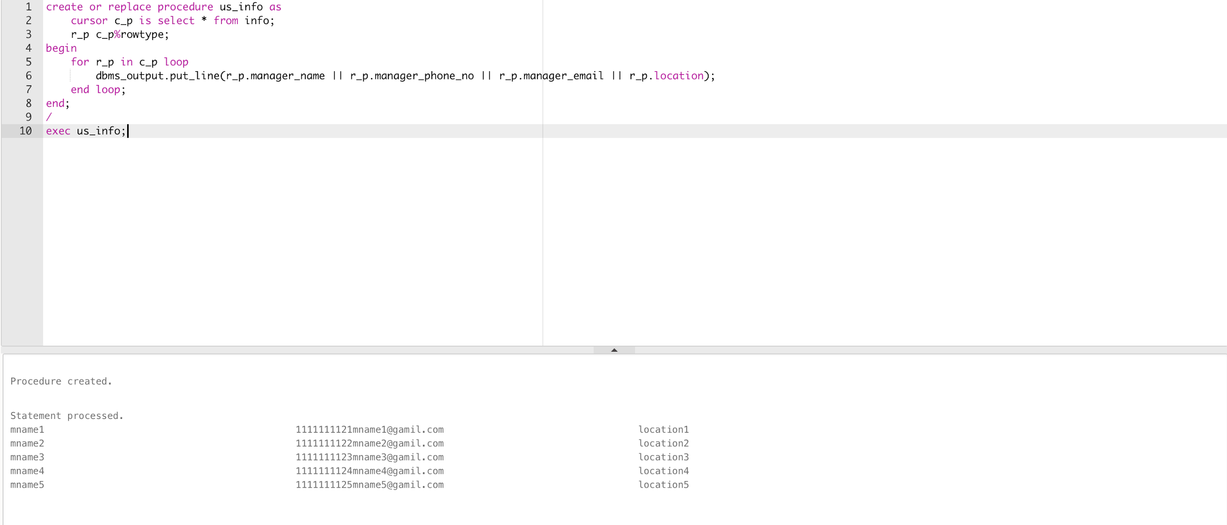

**2. Procedure (Driver Details)**

create or replace procedure driv_no as

cursor c_p is select * from driver;

r_p c_p%rowtype;

begin

for r_p in c_p loop

dbms_output.put_line(r_p.driver_id || r_p.driver_name || r_p.phone_no);

end loop;

end;

/

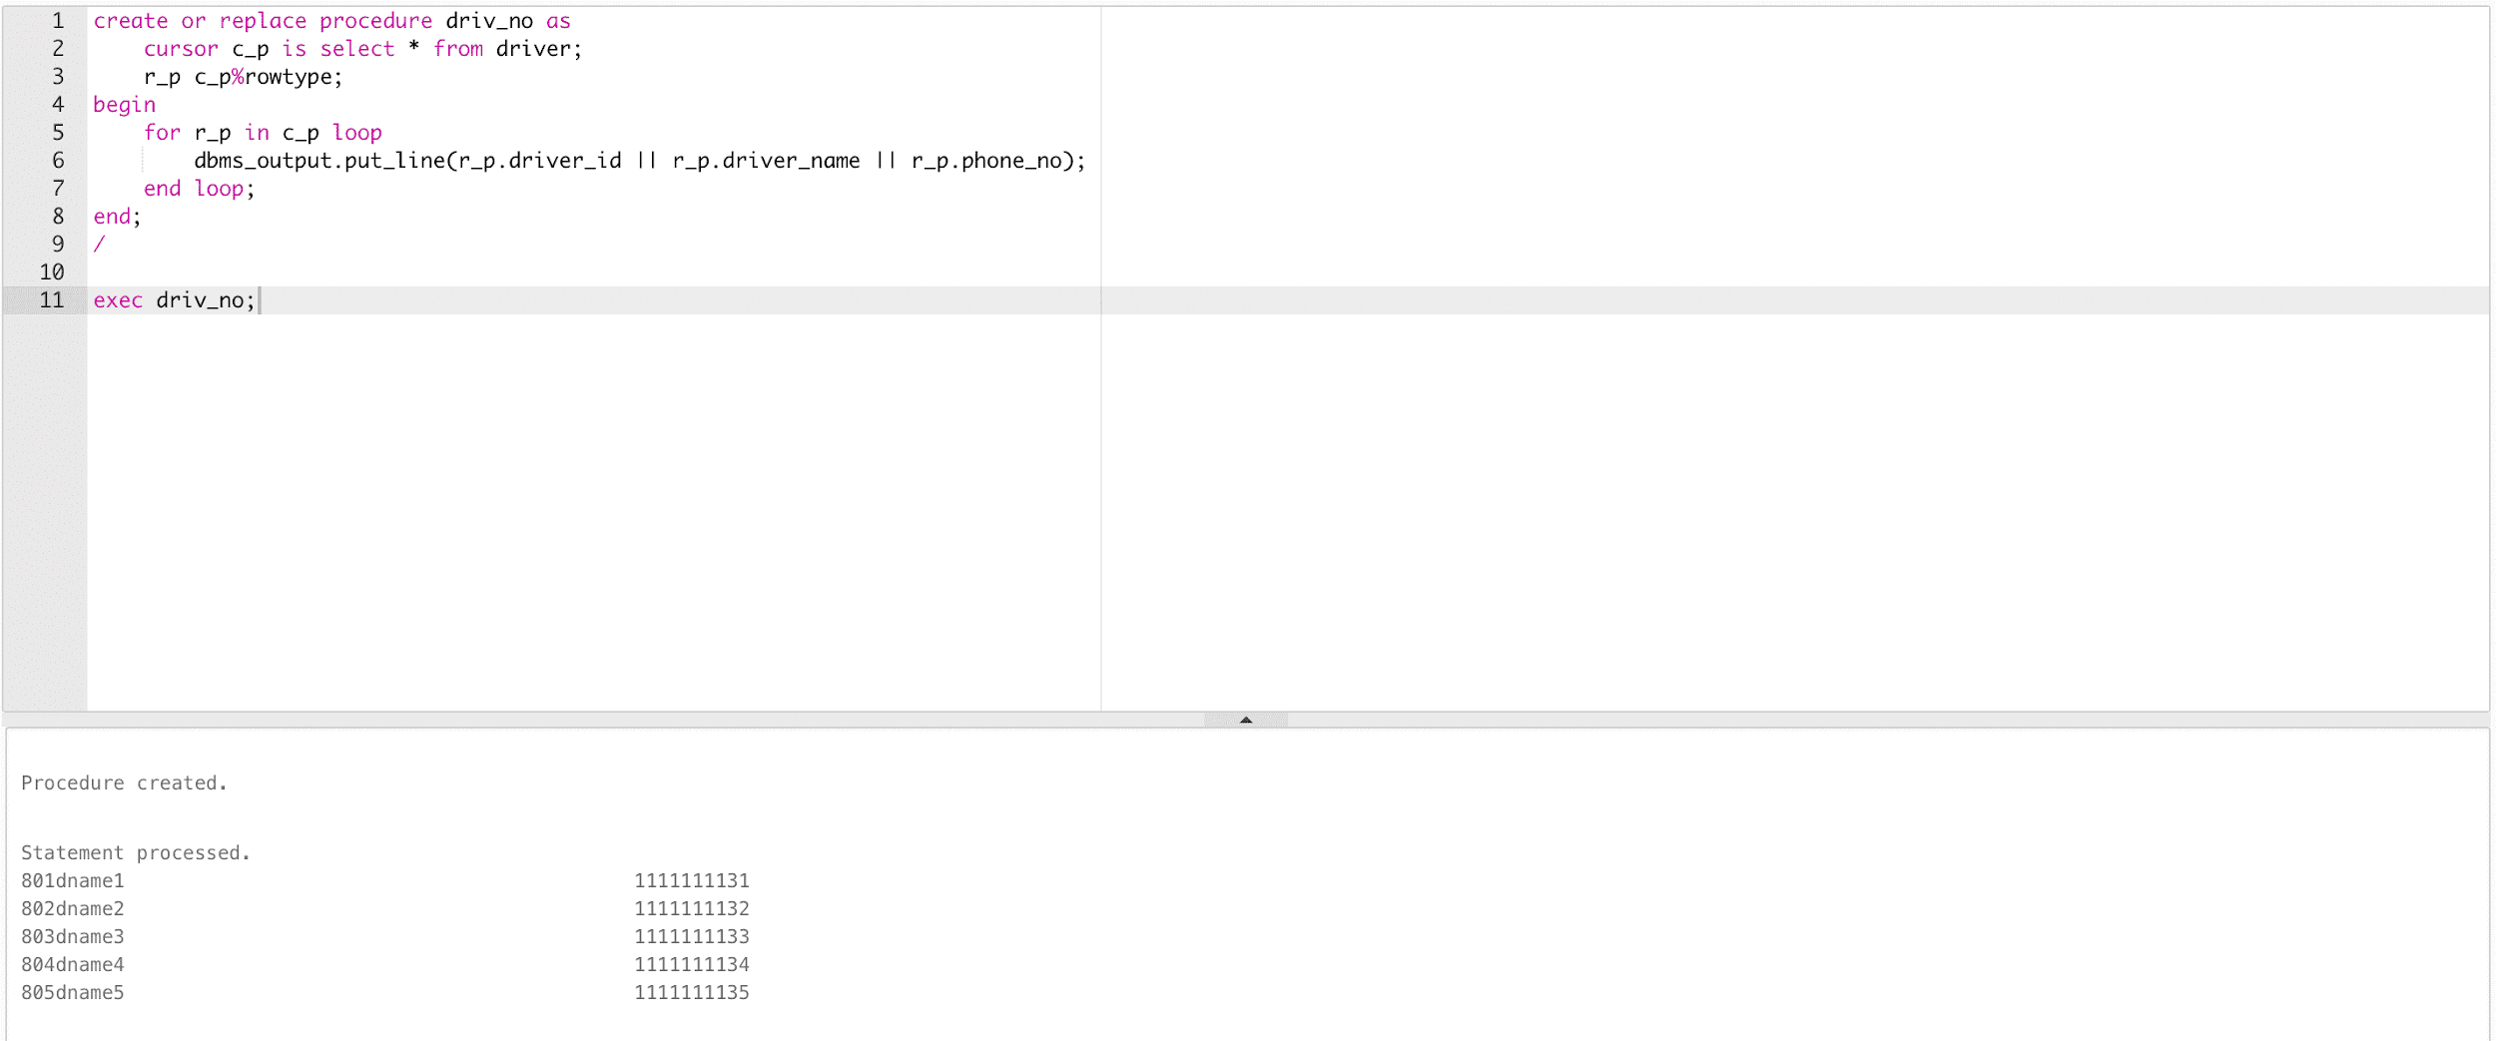

## **Function**

**1. Function (User Wants to Update Details)**

create or replace function update_data(id int, name char, mail char, age int, gender char, phone int) return int as

cursor c_p is select * from us_er;

r_p c_p%rowtype;

begin

for r_p in c_p loop

update us_er set user_name = name, user_mail = mail, user_age = age, user_gender = gender, user_phone_no = phone where r_p.user_id = id;

end loop;

dbms_output.put_line('successfully updated!');

return null;

end;

/

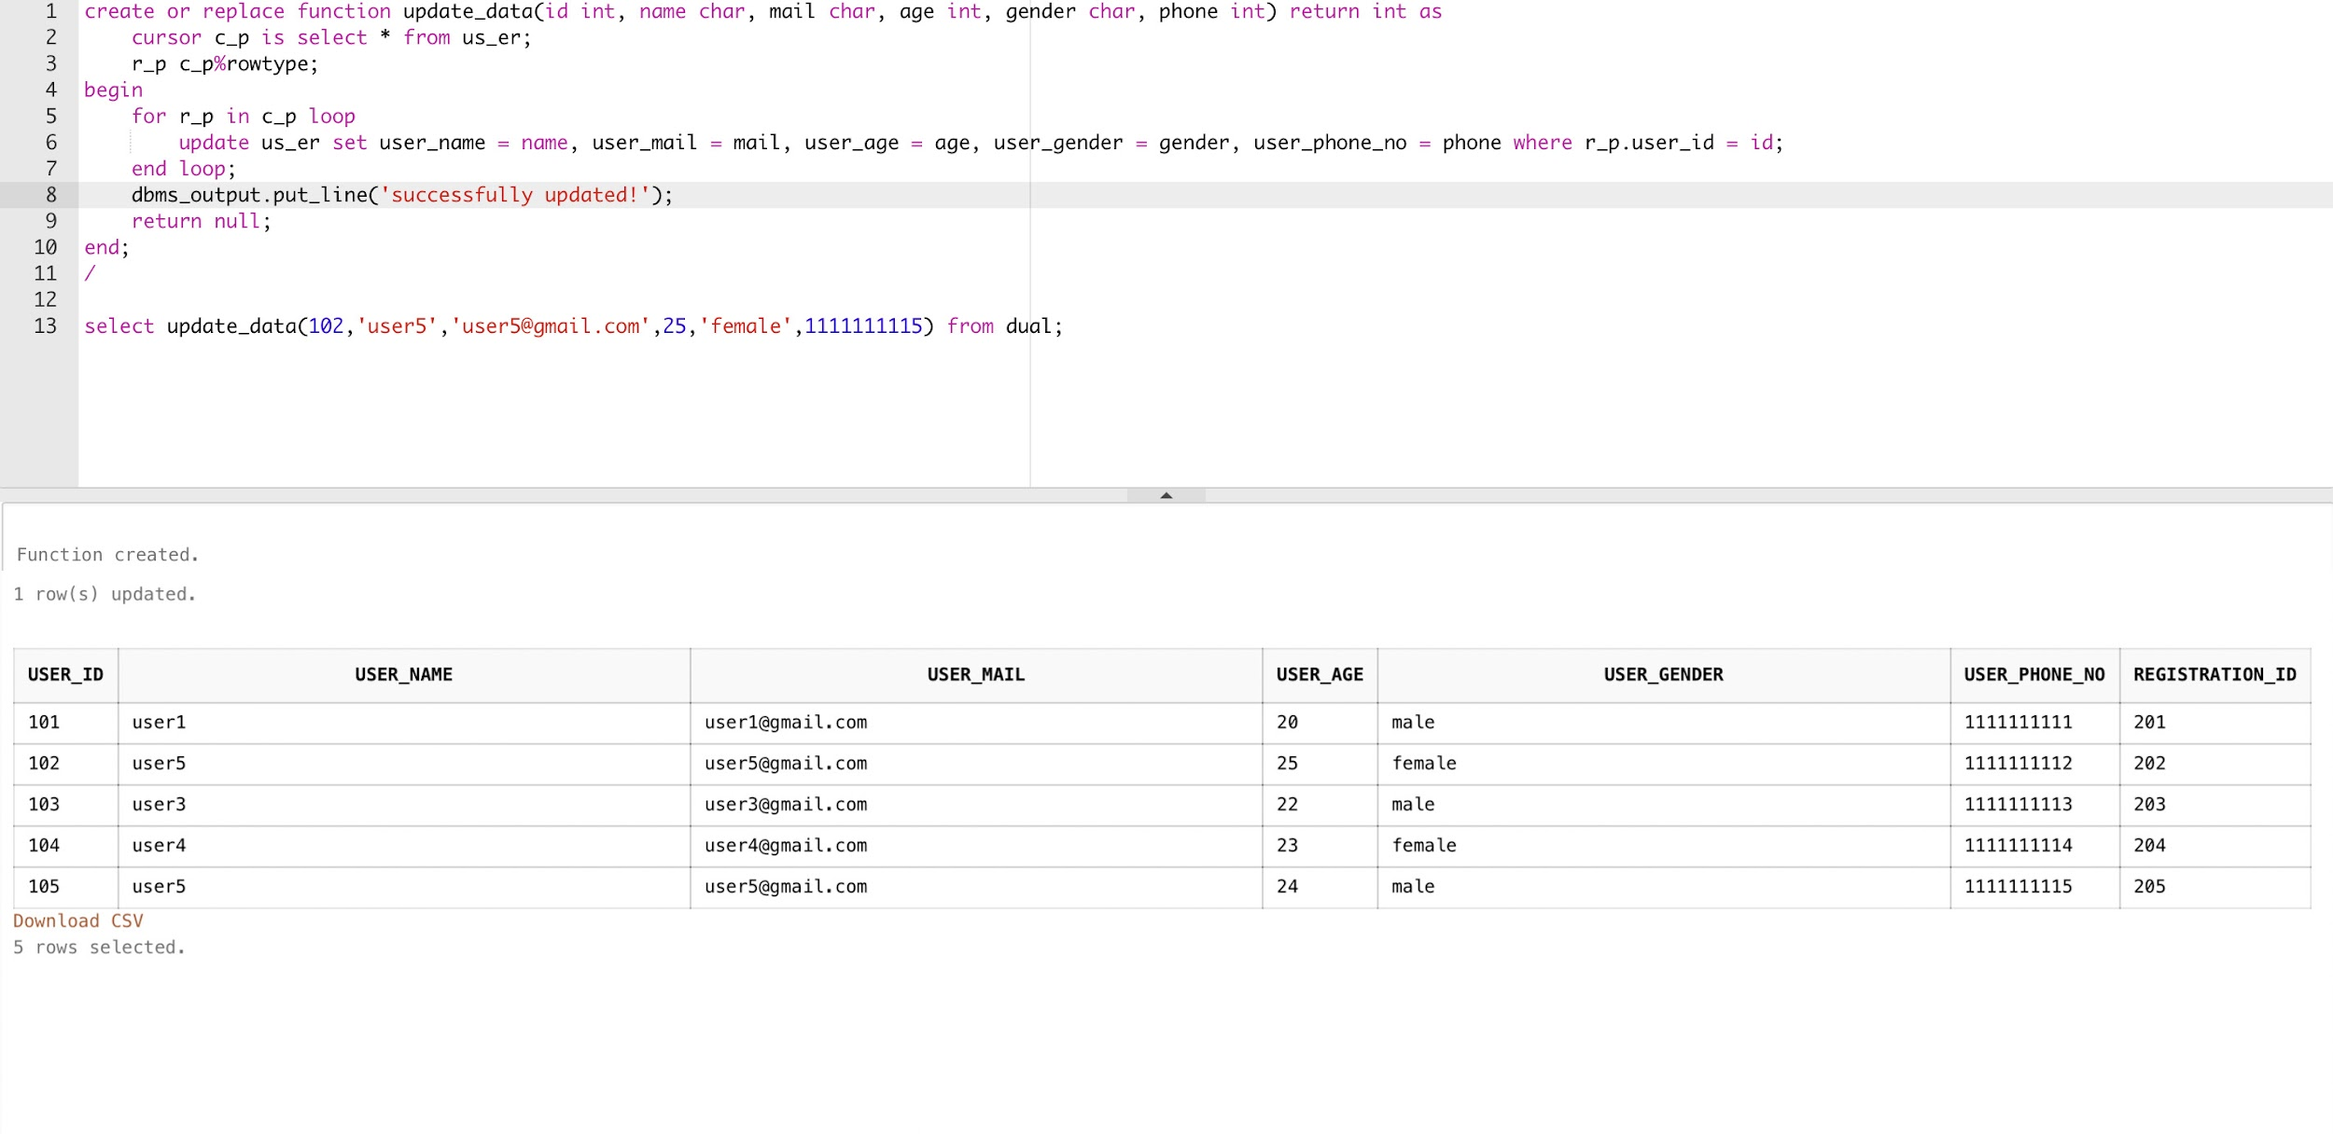

**2. Function (Government and Private Details)**

create or replace function disp_details(p_id int, g_id int, pg_unable int) return int as

cursor c_p1 is select * from government;

r_p1 c_p1%rowtype;

cursor c_p2 is select * from private;

r_p2 c_p2%rowtype;

begin

if(pg_unable = 0) then

for r_p1 in c_p1 loop

if(r_p1.gov_id = g_id) then

dbms_output.put_line(r_p1.gov_no || r_p1.gov_area || r_p1.manager_id);

end if;

end loop;

else

for r_p2 in c_p2 loop

if(r_p2.private_id = p_id) then

dbms_output.put_line(r_p2.private_name || r_p2.private_area || r_p2.price || r_p2.manager_id);

end if;

end loop;

end if;

return null;

end;

/

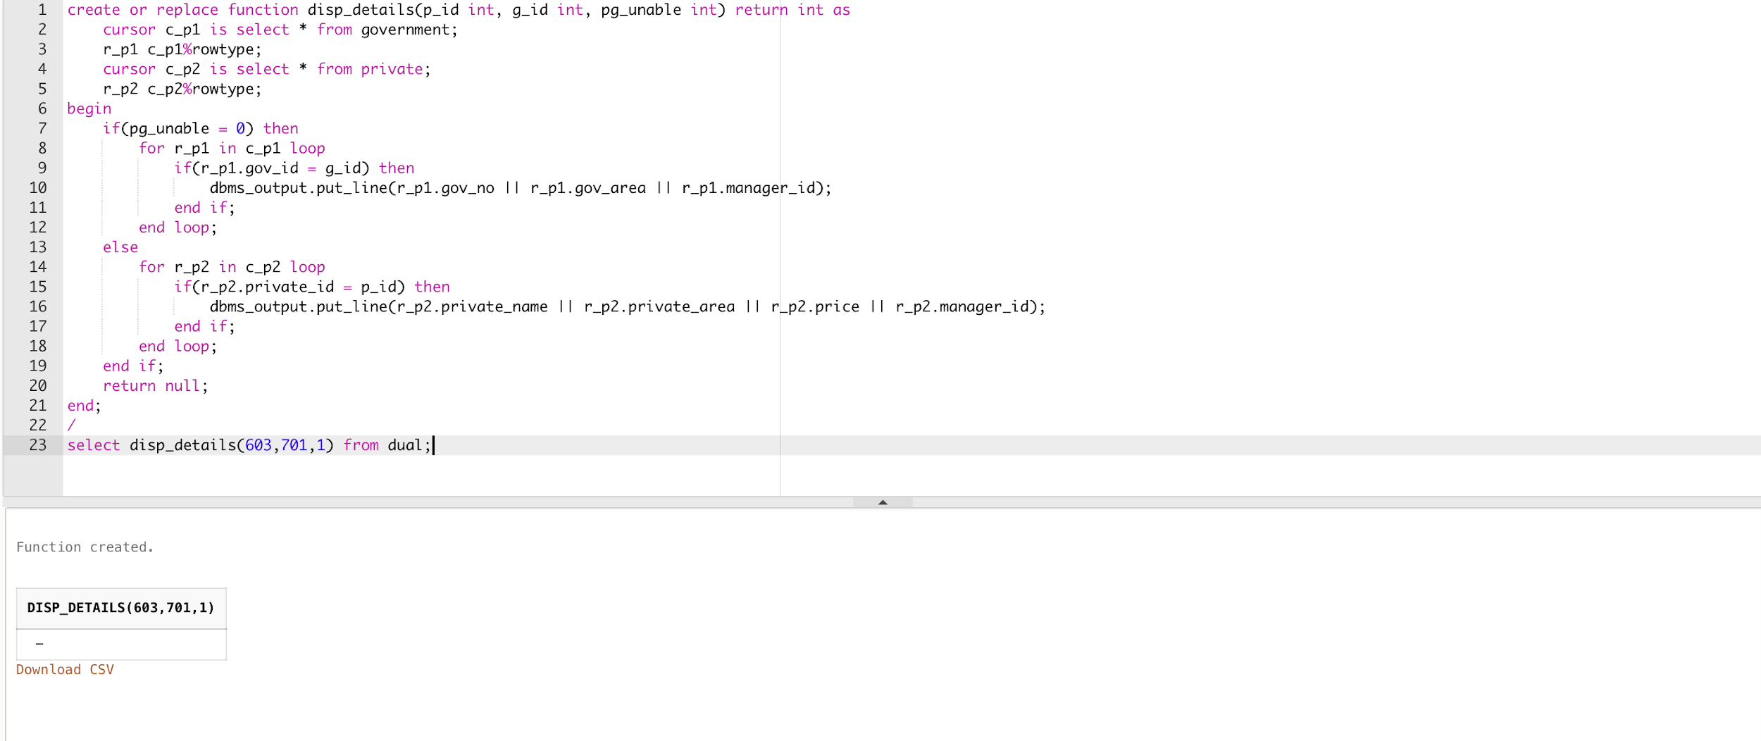

**3. Function (Supply Details)**

create or replace function sho_supp(sup_id int, i_d int) return int as

cursor c_p is select * from supply;

r_p c_p%rowtype;

begin

for r_p in c_p loop

if(sup_id = r_p.supply_id and i_d = 0) then

dbms_output.put_line(r_p.supply_id || r_p.supply_date || r_p.supply_time || r_p.supply_status || r_p.gov_id);

else

dbms_output.put_line(r_p.supply_id || r_p.supply_date || r_p.supply_time || r_p.supply_status || r_p.private_id);

end if;

end loop;

return null;

end;

/

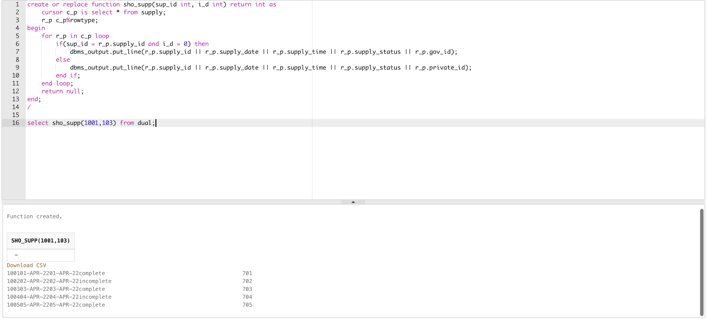

**4. Function (displays all complain given by user for waste)**

create or replace function usr_comp(usr_id int, com_id int) return int as

cursor c_p1 is select * from waste;

r_p1 c_p1%rowtype;

cursor c_p2 is select waste_id, user_id, complain_id, description from complain;

r_p2 c_p2%rowtype;

begin

for r_p2 in c_p2 loop

for r_p1 in c_p1 loop

if(usr_id = r_p2.user_id and com_id = r_p2.complain_id and r_p1.waste_id = r_p2.waste_id) then

dbms_output.put_line(r_p2.complain_id || r_p2.waste_id || r_p1.waste_type || r_p1.waste_eight || r_p1.waste_unit || r_p2.description);

end if;

end loop;

end loop;

return null;

end;

/

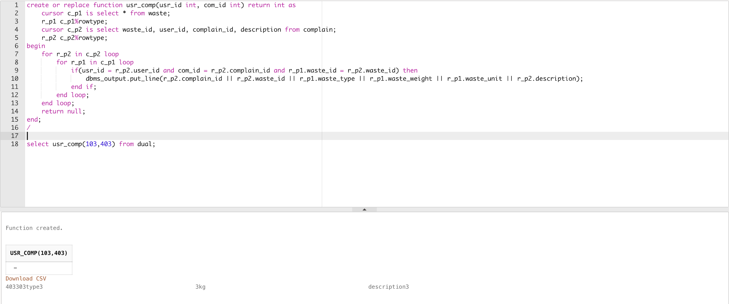

**5. Function (User Details)**

create or replace function usr_dt(usr_id int) return int as

cursor c_p is select * from us_er;

r_p c_p%rowtype;

begin

for r_p in c_p loop

if(r_p.user_id = usr_id) then

dbms_output.put_line(r_p.user_name || r_p.user_id || r_p.user_mail || r_p.user_age || r_p.user_gender || r_p.user_phone_no);

end if;

end loop;

return null;

end;

/

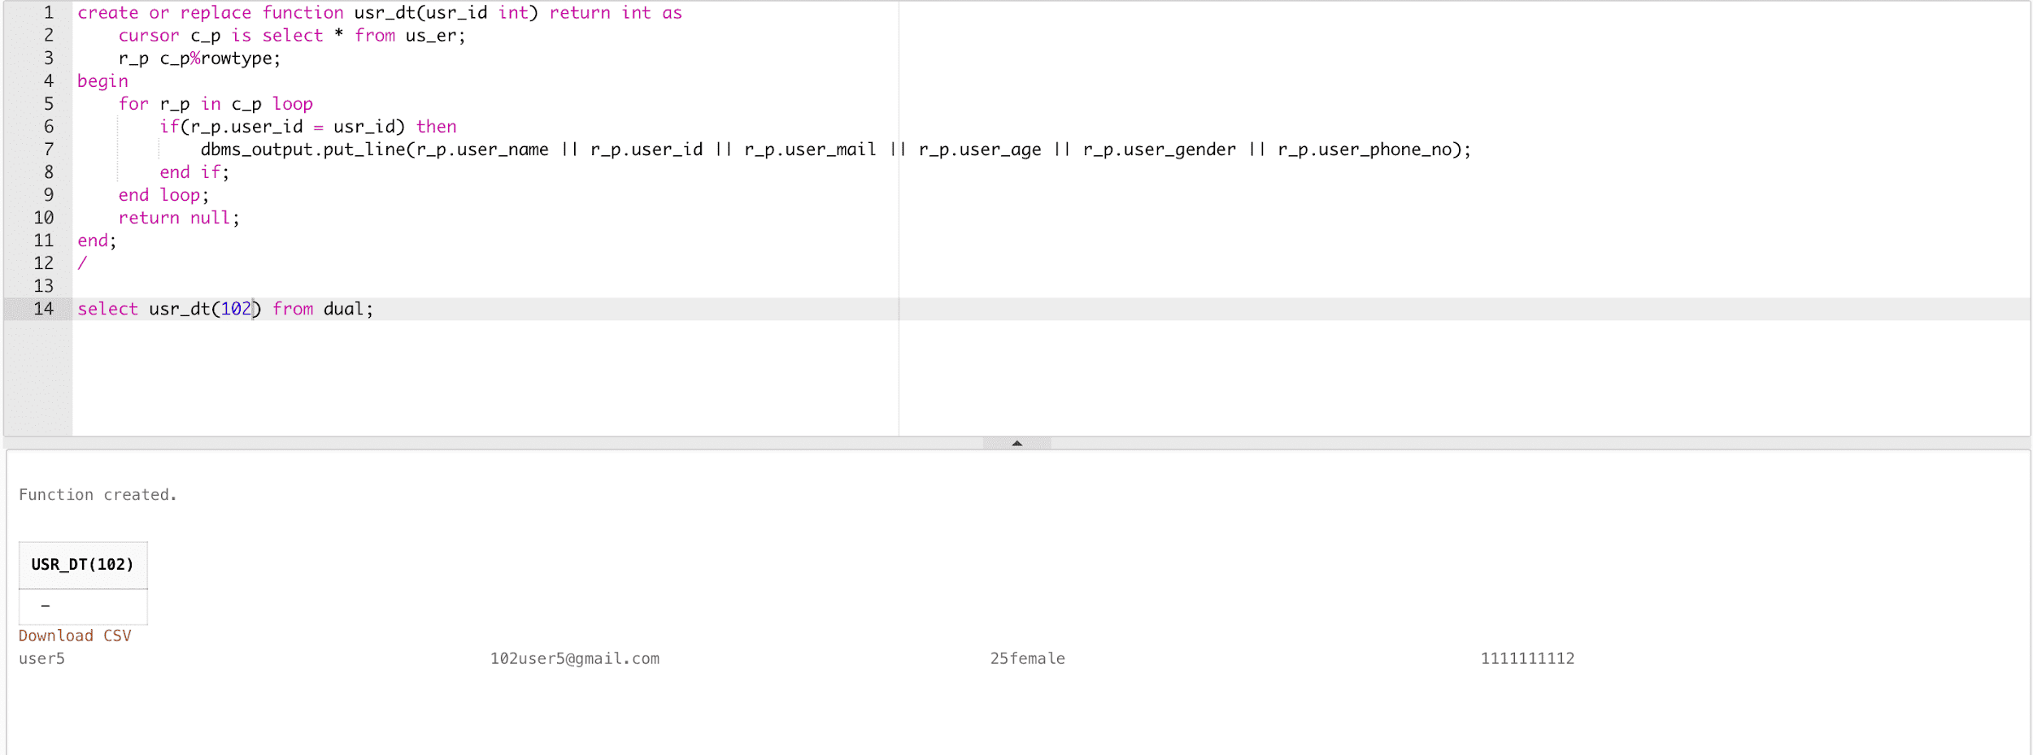

**6. Function (display complain history of a user)**

create or replace function view_history(usr_id int) return int as

cursor c_p is select * from history;

r_p c_p%rowtype;

begin

for r_p in c_p loop

if(r_p.user_id = usr_id) then

dbms_output.put_line(r_p.user_id || r_p.driver_id || r_p.gov_id || r_p.private_id || r_p.waste_id);

end if;

end loop;

return null;

end;

/

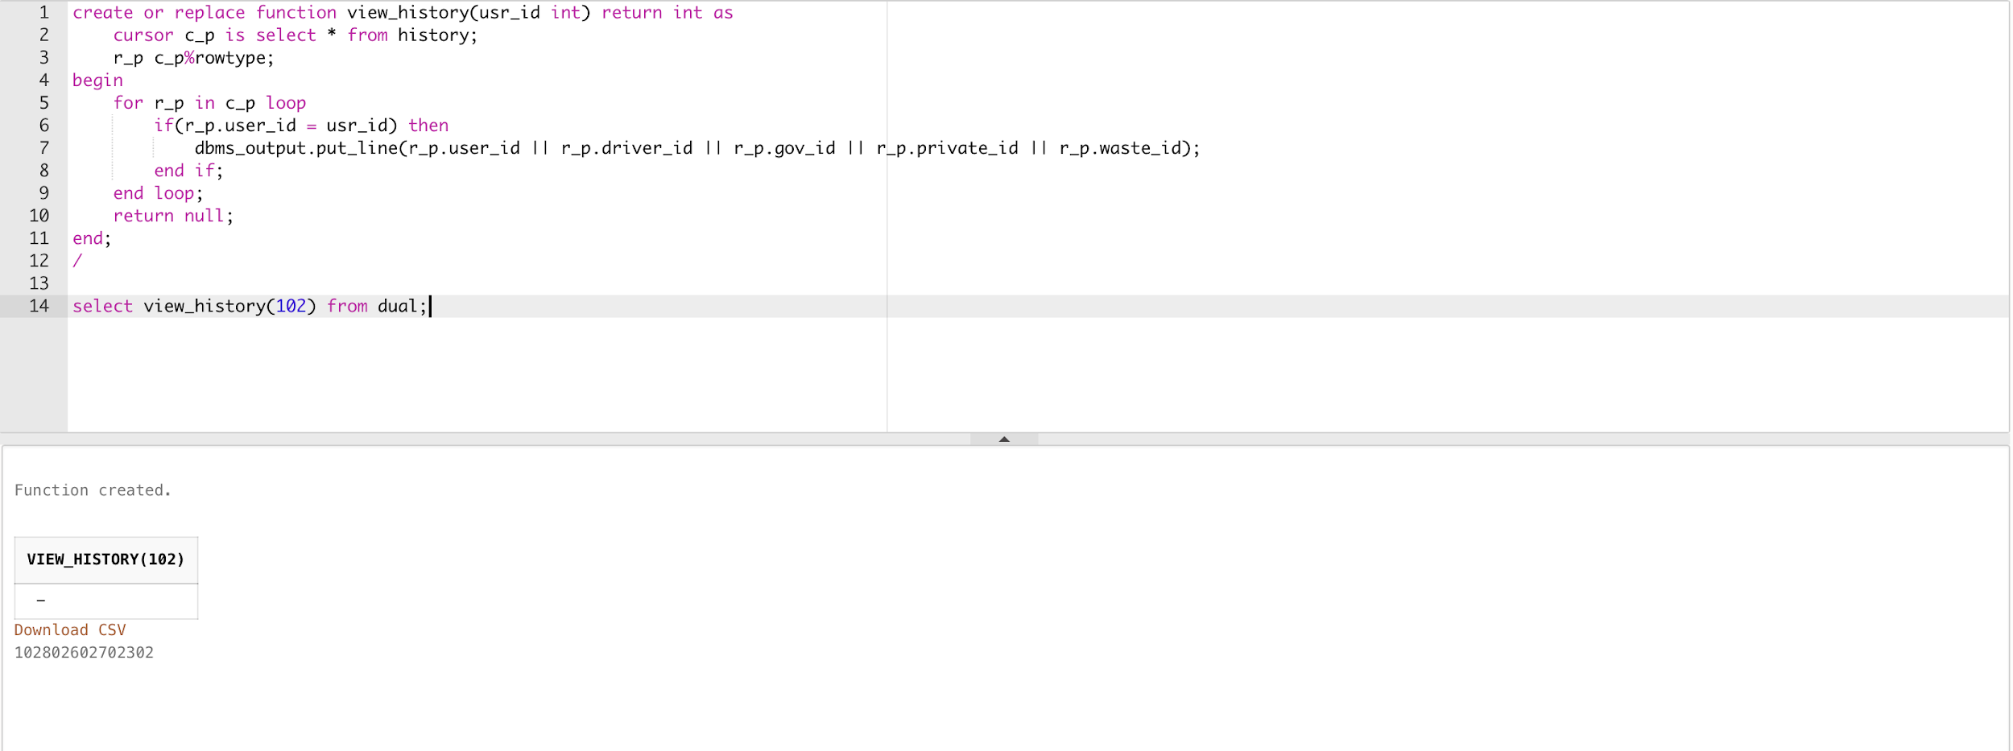

**7. Function (Use if user wants to delete the complain)**

create or replace function del_com(com_id int, usr_id int) return int as

cursor c_p is select user_id, complain_id from complain;

r_p c_p%rowtype;

begin

for r_p in c_p loop

if (com_id = r_p.complain_id and usr_id = r_p.user_id) then

delete from complain where complain_id = com_id;

end if;

end loop;

return null;

end;

/

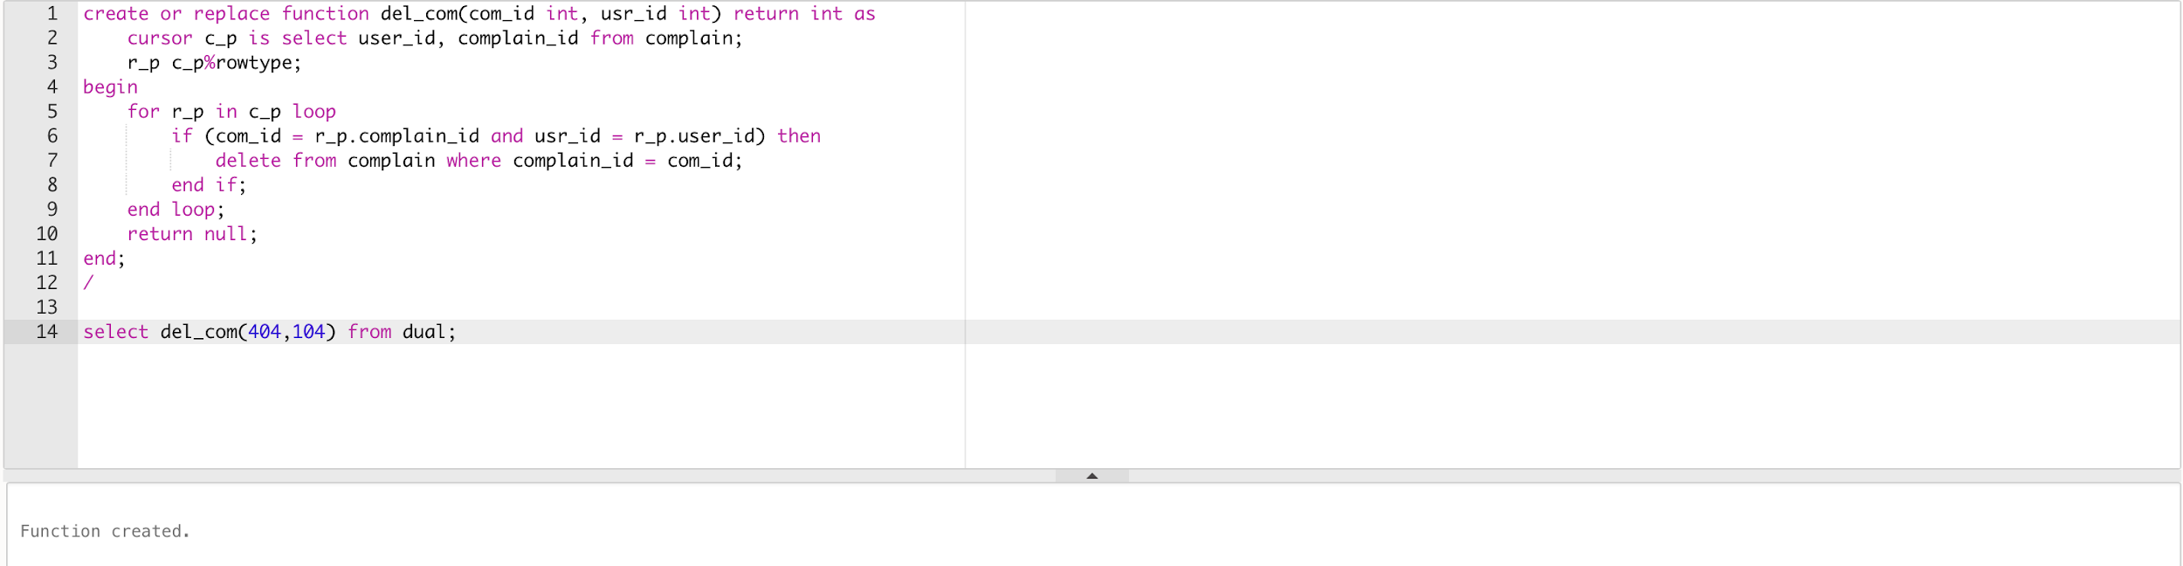

**8. Function (if user wants to update the complain details in complain table)**

create or replace function upd_com(com_id int, usr_id int, wst_id int, wst_ut int, add int, de_sc char) return int as

cursor c_p is select complain_id, user_id from complain;

r_p c_p%rowtype;

begin

for r_p in c_p loop

if(com_id = r_p.complain_id and usr_id = r_p.user_id) then

update complain set waste_id = wst_id, waste_unit = wst_ut, pin_code = add, description = de_sc where r_p.complain_id = com_id;

end if;

end loop;

return null;

end;

/

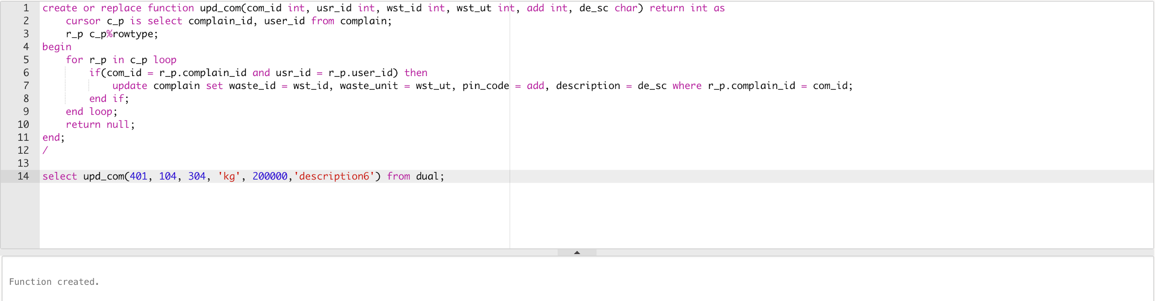

**9. Function (if the company want to update the manager information)**

create or replace function upd_info(mng_id int, mng_name char, mag_no int, mng_mid char, mng_location char) return int as

cursor c_p is select manager_id from info;

r_p c_p%rowtype;

begin

for r_p in c_p loop

if(mng_id = r_p.manager_id) then

update info set manager_name = mng_name, manager_phone_no = mag_no, manager_email = mng_mid, location = mng_location;

end if;

end loop;

return null;

end;

/

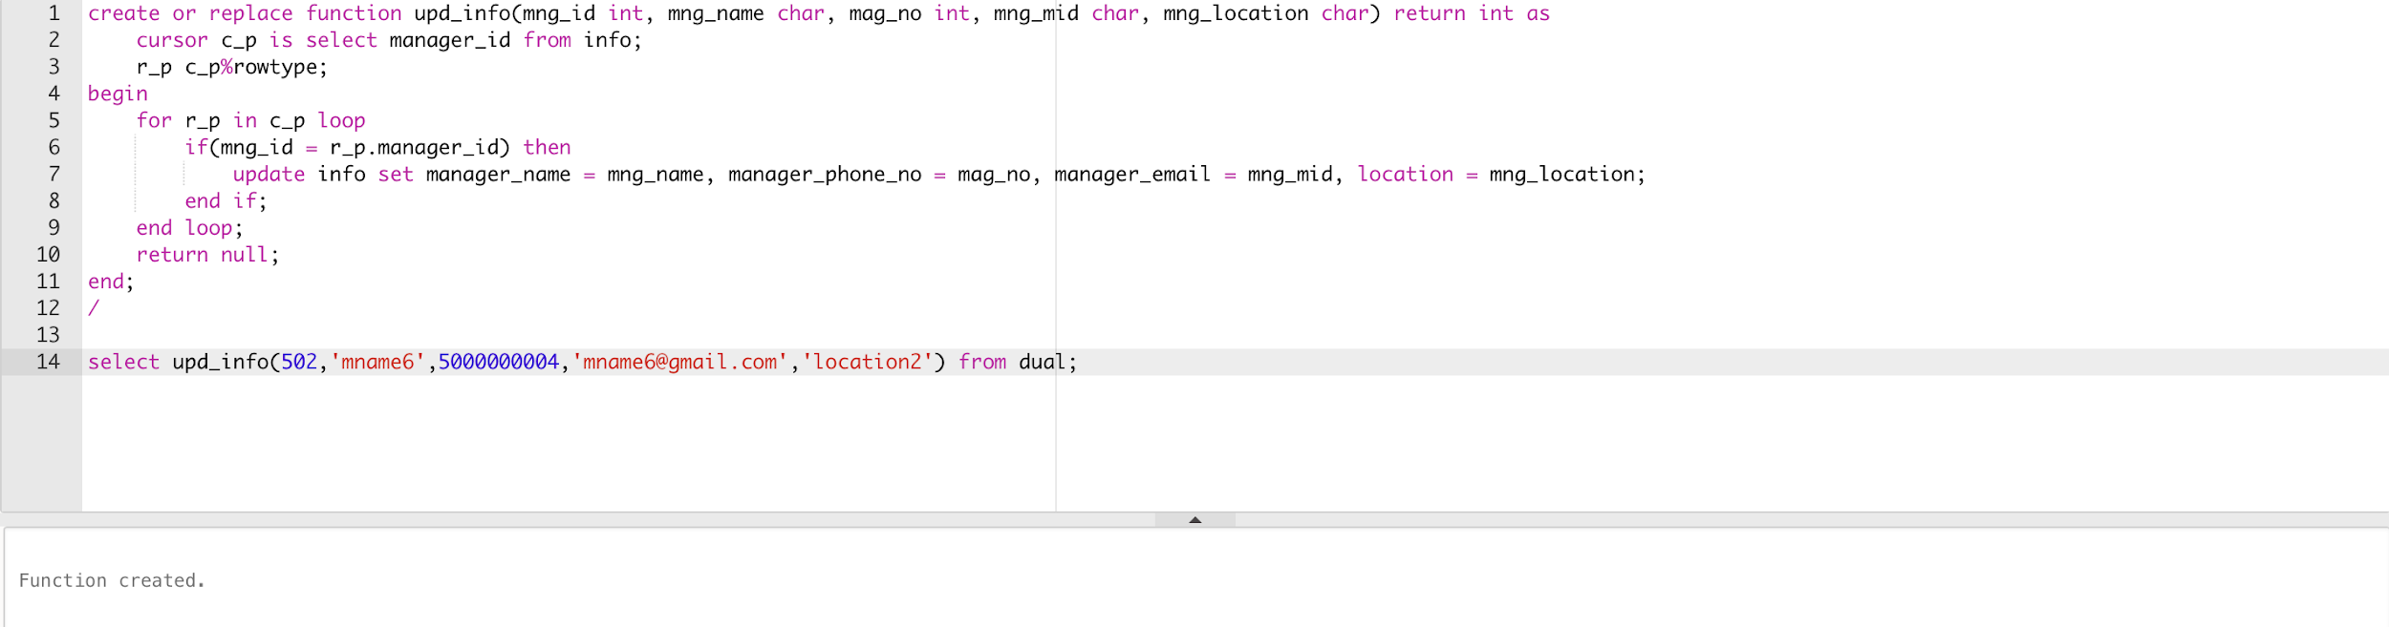

**10. Function (User Log-in Details)**

create or replace function log_in(usr_email char) return int as

cursor c_p is select user_mail from us_er;

r_p c_p%rowtype;

begin

for r_p in c_p loop

if(r_p.user_mail = usr_email) then

dbms_output.put_line('Access Granted for the account');

else

dbms_output.put_line('email not found, create your account');

end if;

end loop;

return null;

end;

/

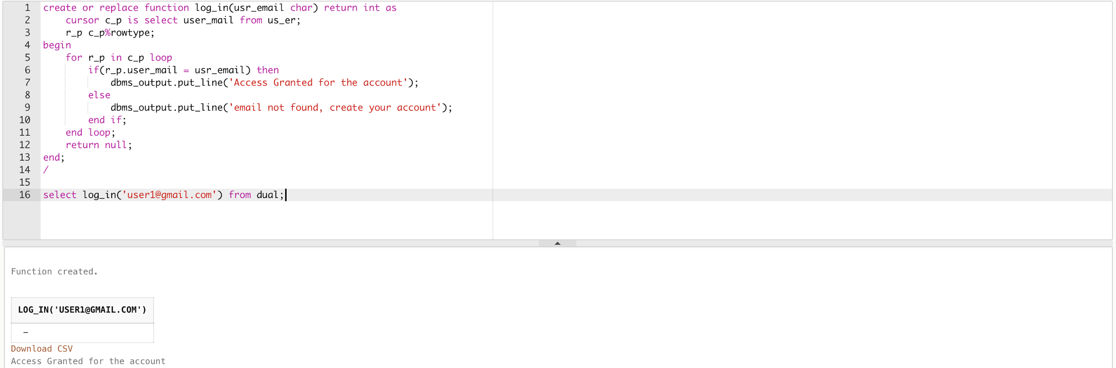

## **Trigger**

**1. Trigger (Waste id and User id Insert to User_Waste)**

create or replace trigger waste_usr after insert on complain

for each row

begin

insert into waste_user values(:new.user_id,:new.waste_id);

end;

/

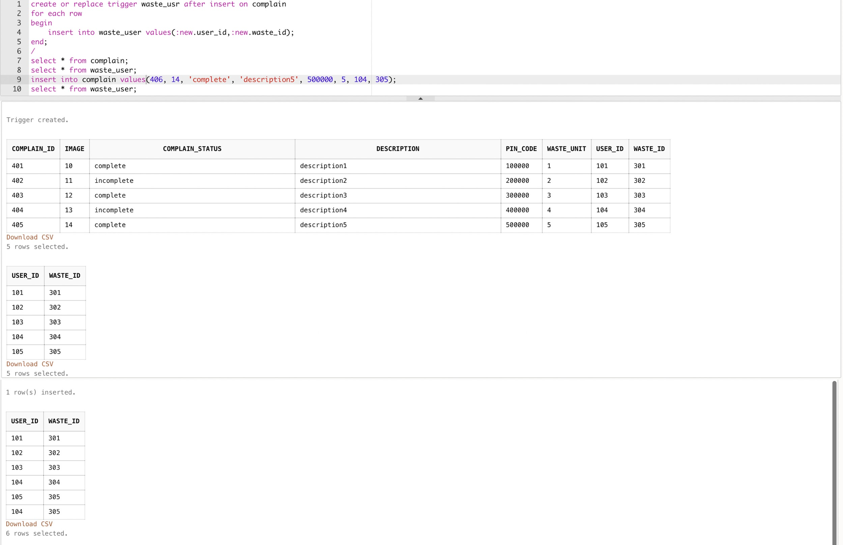

**2.Trigger (Government Private Trigger)**

create or replace trigger comp_add after insert on complain

for each row

declare

cursor c_p1 is select area from customer_address;

r_p1 c_p1%rowtype;

cursor c_p2 is select gov_area, gov_name from government;

r_p2 c_p2%rowtype;

cursor c_p3 is select private_area, private_name from private;

r_p3 c_p3%rowtype;

chk1 int;

chk2 int;

begin

chk1 := 0;

chk2 := 0;

for r_p1 in c_p1 loop

for r_p2 in c_p2 loop

if(r_p1.area = r_p2.gov_area) then

dbms_output.put_line(r_p2.gov_name);

chk1 := 1;

end if;

end loop;

for r_p3 in c_p3 loop

if(r_p1.area = r_p3.private_area) then

dbms_output.put_line(r_p3.private_name); chk2 := 1;

end if;

end loop;

end loop;

if(chk1 = 0) then

dbms_output.put_line(‘Service not found in your area’);

end if;

if(chk2 = 0) then

dbms_output.put_line(‘Service not found in your area’);

end if;

end;

/

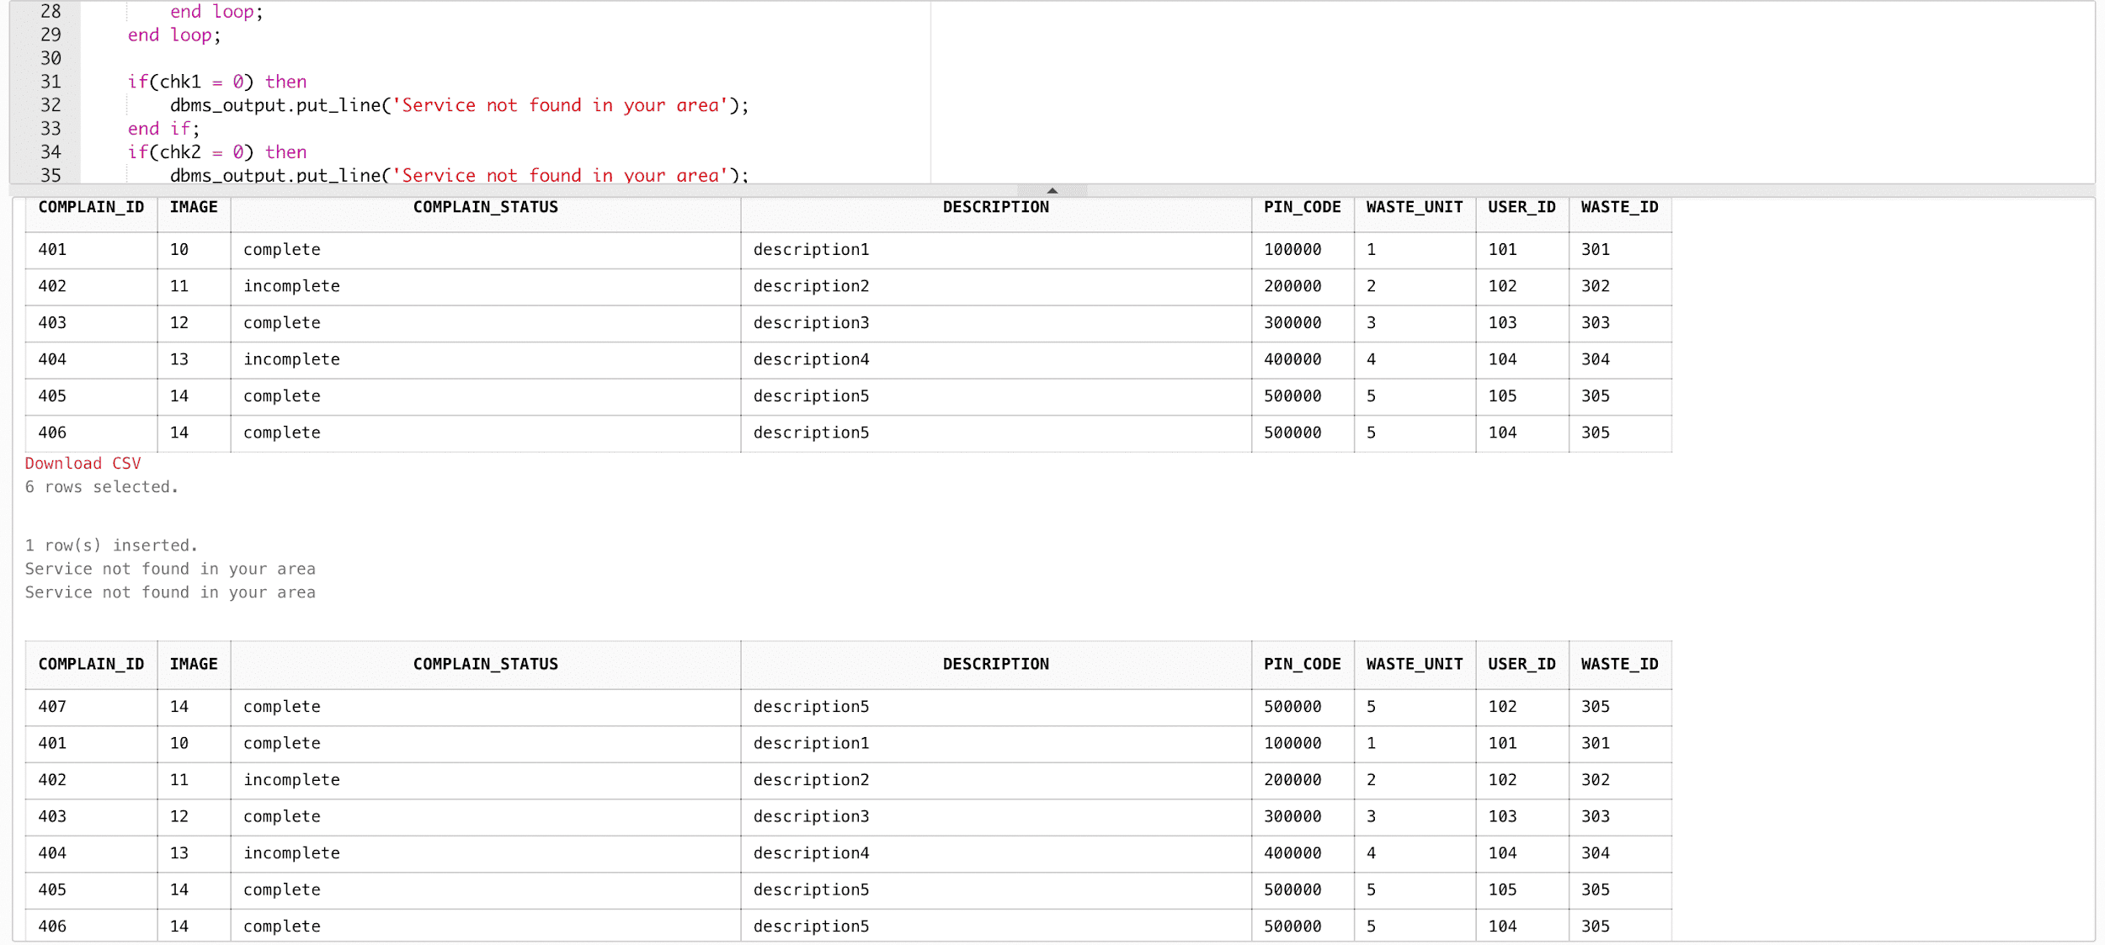

**3. Trigger (separating the data inserted by user while complaining and separated into complain and waste table)**

create or replace trigger sep_tem after insert on temp

For each row

begin

insert into complain values(:new.complain_id, :new.image, :new.complain_status, :new.description, :new.pin_code, :new.waste_unit, :new.user_id, :new.waste_id);

insert into waste values(:new.waste_id, :new.waste_type, :new.waste_weight, :new.waste_unit);

end;

/

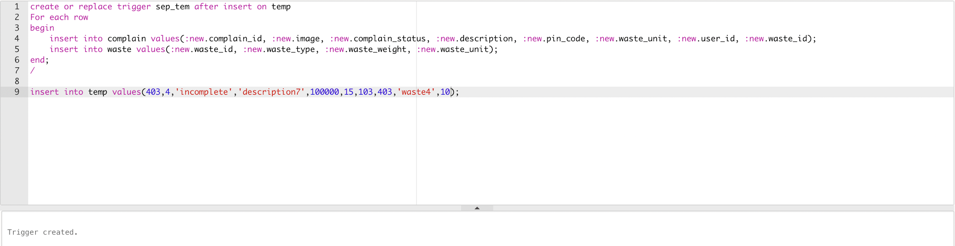

**4. Trigger (if there is no service in user area display the error)**

create or replace trigger chk_ser after insert on temp2

for each row

declare

cursor c_p1 is select area from temp2;

r_p1 c_p1%rowtype;

cursor c_p2 is select gov_area from government;

r_p2 c_p2%rowtype;

cursor c_p3 is select private_area from private;

r_p3 c_p3%rowtype;

begin

for r_p1 in c_p1 loop

for r_p2 in c_p2 loop

for r_p3 in c_p3 loop

if(r_p1.area = r_p2.gov_area or r_p1.area = r_p3.private_area) then

dbms_output.put_line('Address Added');

insert into customer_address values(:new.pin_code, :new.user_id, :new.street, :new.area, :new.city, :new.state, :new.country);

else

dbms_output.put_line('No service found in your area!');

end if;

end loop;

end loop;

end loop;

end;

/

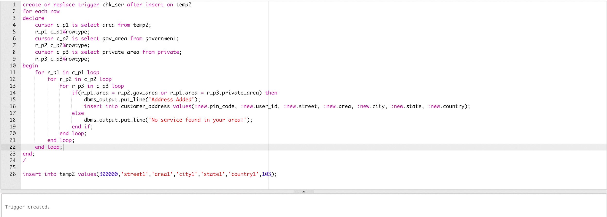

**5. Trigger (Discount on the price of private sector)**

create or replace trigger disk_prc after insert on private

for each row

declare

cursor c_p1 is select * from private;

r_p1 c_p1%rowtype;

cursor c_p2 is select * from waste;

r_p2 c_p2%rowtype;

cursor c_p3 is select * from history;

r_p3 c_p3%rowtype;

discount int;

begin

for r_p1 in c_p1 loop

for r_p2 in c_p2 loop

for r_p3 in c_p3 loop

if(r_p1.private_id = r_p3.private_id and r_p2.waste_id = r_p3.waste_id) then

if(r_p2.waste_weight > 10 and r_p2.waste_weight <= 20) then

discount := (r_p1.price*5)/100;

dbms_output.put_line('Discount = '||discount);

elsif(r_p2.waste_weight >20 and r_p2.waste_weight <= 30) then

discount := (r_p1.price*10)/100;

dbms_output.put_line('Discount = '||discount);

elsif(r_p2.waste_weight > 30 and r_p2.waste_weight <= 40) then

discount := (r_p1.price*15)/100;

dbms_output.put_line('Discount = '||discount);

elsif(r_p2.waste_weight > 40) then

discount := (r_p1.price*20)/100;

dbms_output.put_line('Discount = '||discount);

else

dbms_output.put_line('Discount = 0');

end if;

end if;

end loop;

end loop;

end loop;

end;

/

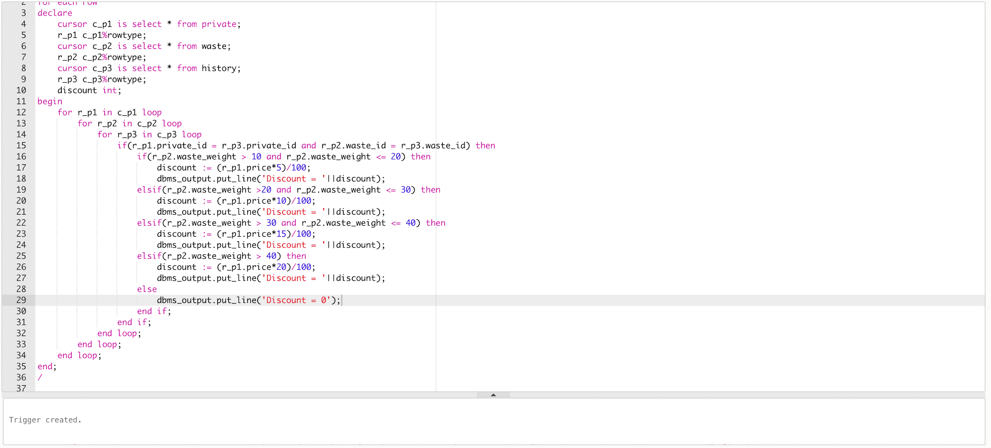

# Website (Frontend)

## **Home Page**



This is the first page of the website, so if the user is already a user then they directly Log in to the website. If they are first time on the website, then they can login through the join now option or sign up option.

## **Login Page**

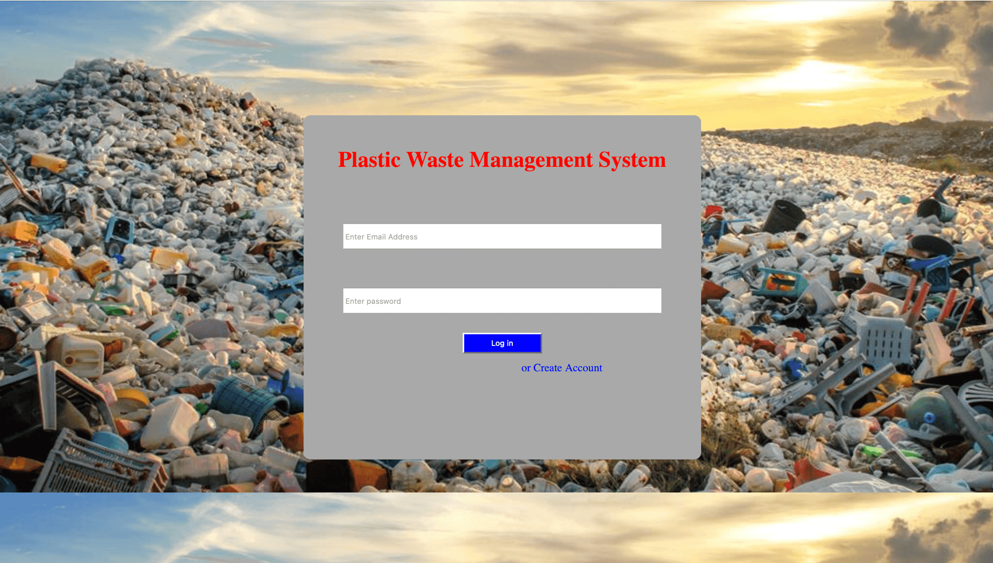

After pressing the login button, the input data will be checked into the database and if the user is verified then a direct dashboard will appear of the users which contain user details, user complaint history, complaint status and many more.

## **Sign up Page**

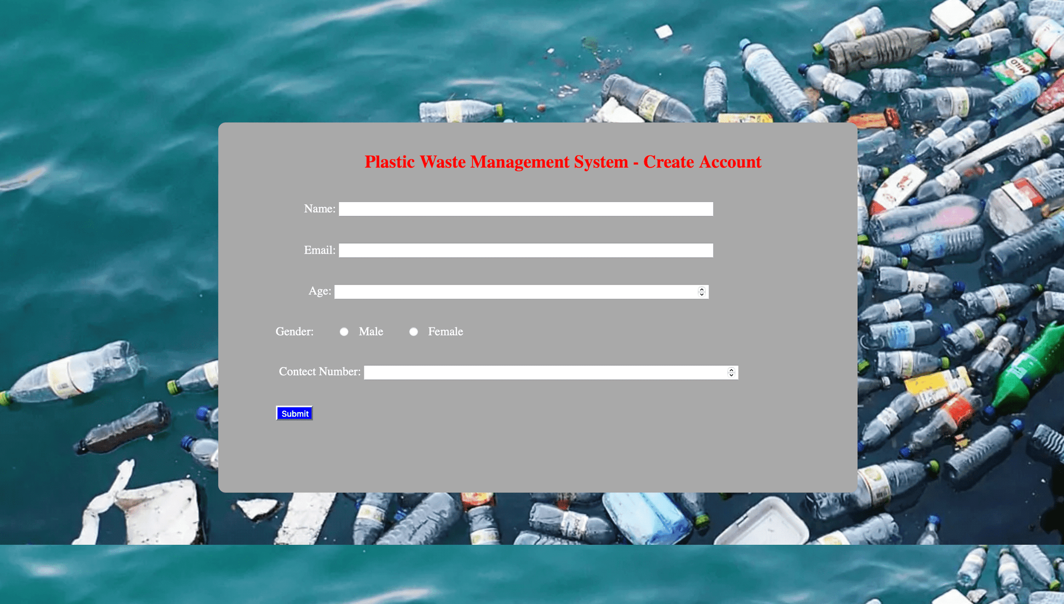

If function can’t find the email and password in database, then they are directly transferred to Sign up page, or when some click Sign up from home page or some one click Create account from Log in page.

Thankyou